RADIATION SAFETY ANALYSIS of NEUTRON COLIMATOR based on NICKEL MATERIAL FOR PIERCING RADIAL BEAMPORT utilization OF KARTINI RESEARCH REACTOR.

Widarto1, Toto Trikasjono2, Isman Mulyadi T1, Faizal Akbar2

1. Center for Accelerator Science and Technology-National Nuclear Energy Agency of Indonesia
2. Nuclear Technology School of Higher Learning-National Nuclear Energy Agency of Indonesia

ABSTRACT

Radiation safety analysis of nickel material neutron colimator (as requirement) for pearcing radial beamport utilization of Kartini research reactor has been done before the neutron colimator instaled. The neutron collimator made of nickel material with cyllindrical geometry which is 156 cm length. The Inside and outside diameter are 16 cm and 19 cm respectively with mean cyllindrical thickness is 1,5 cm.Irradiation process to the neutron collimator begin when the reactor beeing operated for 6 (six) hours per day and assumed optimum at 100 kW power level. Results of the analysis showed that gamma dose rate which was generated by collimator at a distance of 50 cm from the end of the collimator is 1,5328e-03 mr/hours. The dose rate is still below the dose limit value which was required by Nuclear Energy Regulatory Agency (BAPETEN) is 1 mr/hours. It can be concluded that utilization neutron colimator of nickel material which installed at the radial pierching beamport of Kartini Reactor is safelly.

**Keywords:** neutron collimator, pierching radial beamport, radiation, dose rate.

INTRODUCTION

The development of nuclear technology utilization is increasing in various field such as industry, medicine, agriculture and research. Besides the benefit of nuclear technology utilization contained potential risk to human live and environment. So that it need to maintain and analyze radiation safety for workers, society, and environment.

There are two methods for monitoring to provide protection to human live by exposure of radiation, namely the monitoring of radiation exposure on the workplace and the monitoring of radiation exposure to personnel who work in potential radiation facility.

For radiation safety purpose, requires radiation personal dose limit value assigned by Nuclear Energy Regulatory Agency (BAPETEN). According to regulation by The Head of BAPETEN State No. 4 2013, the personal radiation dose limit value is average effective dose of 20 mSv of five-year period,

so the dose accumulated in 5 years should not exceed 100 mSv. While effective radiation dose limit value for community is 1 mSv per year.

To improve the utilization of the Kartini research reactor, one of irradiation facility that is radial pearcing beamport will be used for in vivo/in vitro neutron irradiation test facility as a basic research for developing Boron Neutron Capture Therapy (BNCT) method. By instaling neutron collimator of nickel material in the radial piercing beamport used for optimizing of neutron.

Before the neutron collimator inserted in the radial piercing beamport, it should be carried out to analysis especially radiation safety aspect, because assume when the collimator in the beamport will be radioactive material because of neutron interaction when the reactor operated at power level. By the analysis of radiation safety aspect it can be used for basic requirement developing utilzation of the Kartini research reactor.

basic ThEORI

Radiation Efect to Human Live.

The main biological effects of radiation is damaging the cells and tissues of the human body. Type the biological effects of radiation can be classified into two types, namely:

1. *Stochastic radiation effects severity is not dependent on the size of the dose and the probability of no specific threshold dose*.
2. *Deterministic radiation effects severity is dependent on large doses*.

Collimator.

Determination of mass the collimator of nickel is useful for determining of radiation exposure when the collimator activated by neutron since inserting in the beamport and being activation process when the reactor is operated at power level. Figure 1. Indicate dimension of cylindrical collimator form with with size of length is 156 cm, outside diameter is 19 cm and inside diameter is 16 cm, mean the thickness of colimator is 1,5 cm.

Neutron Activation.

Neutron activation is reaction betwen material atomic nuclei with neutron when the material put on the neutron field. By neutron activation the nuclei will nucleus in an excited state condistion and radioactive emit particles weather α, β, γ or α and γ, β and γ simultaneously.

Activities of material that has been activated can be determined using equation (1).

 (1)

A = activity (Bq)

∑act = macrosscopic crosscection (cm-1)

ϕ = neutron flux (n cm-2 s-1)

V = volume of materials (cm3)

λ = decay time (s-1)

ti = irradiation time (s)

After irradiation process the nuclei material will emmite radiation activity with spesific decay time and value of activity as formula (3) follow,

 (3)

At = decay activity (Bq)

A0 = initiate activity (Bq)

λ = decay time (s)

td = delay time (s)

**Dose Rate** .

Figure 1. is indicate the neutron collimator which will be inserted to radial pierching beamport with cyllindrical form. When the neutron collimator inserted to beamport while reactor operated, it can be assumed that the collimator will be radioactive material. Radiation activity of the collimator should be determine for safety analysis report related with radiation worker and inviroment.

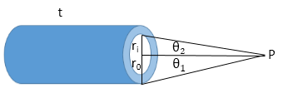

Figure 1. cyllindrical neutron collimator.

Determination dose rate assume that closed position at the distance of point P where area worker done can be calculated by formula (4) follow :

 (4)

where :

ᴦ = gamma factor (R.m2/Ci.jam)

Cv = activity (Ci/m3)

t = length of cilinder (cm)

ri = cyllinder inside diameter (cm)

ro = cyllinder inside diameter (cm)

METHOD

Research Materials.

1. Collimator of Neutron Neutron Collimator

Figure 2. indicate dimension and technical specification of neutron colimator made of nickel material with total length 156 cm separated to 12 segments as follow,

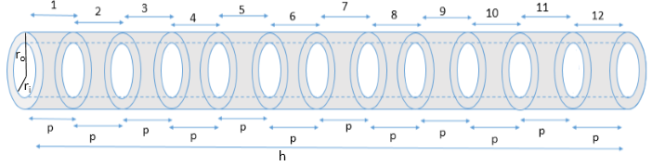

Figure 2. Dimension of neutron collimator

Neutron colimator made of nickel material with cyllindrical dimension and size specification as follow:

Total length (h) = 156 cm

Inside diameter (ri) = 16 cm

Outside diameter (ro) = 19 cm

Segmen length (p) = 13 cm

Total segmen (n) = 12 segmen

Mass each segmen(m) = 8 kg

Total mass (mt) = 96 kg

The nickel purity data of collimator material is arround 95 % which used to manufactured the neutron collimator obtained from studies conducted by Khoirunisa, (2015) with the title "Analysis of Type And Elements Content In Neutron Collimator Materials Before And After Manufacturing Using Neutron Activation Analysis Method (NAA)".

1. Neutron Flux

Neutron flux data along the radial pearcing beamport of Kartini Research Reactor which is operates at 100 kW was studied by Widarto et al, (2014) titled "Current Status of Boron Neutron Capture Therapy Technology Development and Application With Compact Neutron Generator".

**Data Analysis Technique**

Equation (1) was used to determined the mass of each collimator elements. In determining the activity of each collimator elements when irradiation process take place we used equation ( 2 ). In determining the activity of each collimator elements after irradiation process was stopped we used equation ( 3 ). In determining the dose rate generated by collimator used equation ( 4 ).

Result and dscussion

Elements of Neutron Collimator

Research conducted by Khairunnisa, (2015) with the title " Analysis of Type And Elements Content In Neutron Collimator Materials Before And After Manufacturing Using Neutron Activation Analysis Method (NAA)" were obtained the collimator elements before and after manufacturing. Table 1 shows the concentration of constituent elements of neutron collimator after manufacturing.

Tabel 1.Collimator Elements Concentration

|  |  |
| --- | --- |
| Element | Concentration (mg/g) |
| Ni-65 | 6,6506E-02 |
| Mn-56 | 3,8558E-03 |
| Cr-51 | 5,3670E-04 |
| Hg-197m | 1,5047E-04 |
| W-187 | 1,6252E-05 |
| Co-60 | 4,4206E-05 |
| Cu-64 | 1,7392E-05 |

Based on neutron collimator homogeneousity, the mass of each neutron collimator elements in each segment is same. By using equation (1), it will obtain the mass of each neutron collimator elements in each segment. Table 2 shows the mass of each neutron collimator elements in each collimator segment.

Table 2. Mass of Collimator Elements in Each Segment

|  |  |
| --- | --- |
| Unsur | Massa (gram) |
| Ni-65 | 5,3205E-01 |
| Mn-56 | 3,0846E-02 |
| Cr-51 | 4,2936E-03 |
| Hg-197m | 1,2037E-03 |
| W-187 | 1,3002E-04 |
| Co-60 | 3,5365E-04 |
| Cu-64 | 1,3913E-04 |

Neutron Flux

Research conducted by Widarto et al, (2014) titled "Current Status of Technology Development and Application of Boron Neutron Capture Cancer Therapy With Compact Neutron Generator" calculated that the quantity of the thermal and fast neutron flux along the piercing radial beamport when the reactor Kartini operated at a power of 100 kW shown in Table 3. Figure 3 shows the dimensions of the neutron collimator.

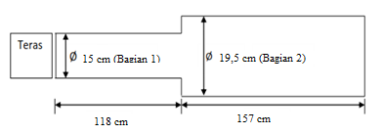

Figure 3. Radial Dimension Translucent Beamport

Table 3. Thermal And Fast Neutron Flux Along The Piercing Radial Beamport

|  |  |  |
| --- | --- | --- |
| Jarak dari Teras (cm) | Fluks Neutron (n cm-2 s-1) | |
| Termal | Cepat |
| 0 | 1,3264E+09 | 1,3130E+09 |
| 25 | 4,1366E+08 | 3,3393E+08 |
| 50 | 4,0303E+08 | 3,9220E+08 |
| 75 | 1,0511E+08 | 8,3272E+07 |
| 100 | 2,0128E+07 | 1,4682E+07 |
| 120 | 8,3678E+06 | 3,3553E+06 |
| 140 | 8,3082E+06 | 1,5311E+06 |
| 160 | 3,0194E+06 | 3,1597E+06 |
| 180 | 5,9255E+06 | 4,5900E+05 |
| 200 | 5,2844E+06 | 4,7344E+05 |
| 220 | 3,6433E+06 | 1,2849E+06 |
| 240 | 4,4010E+06 | 5,2958E+05 |
| 260 | 3,0691E+06 | 9,8243E+05 |

Based on Table 3 data, it can be made a relationship between the beamport length and neutron flux. Figure 4 shows the relationship between the beamport length and thermal neutron flux, while Figure 5 shows the relationship between beamport length with fast neutron flux.

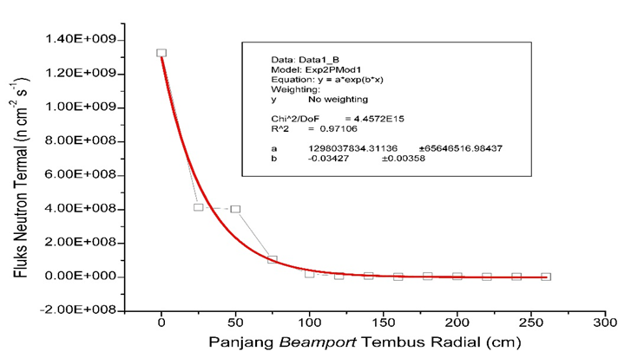

Figure 4. Graph Of Relationship Between The Beamport Length And Thermal Neutron Flux

Equation (5) shows the distribution of thermal neutron flux, where the thermal neutron flux expressed in y-axis and x-axis specifies the beamport length.

 (5)

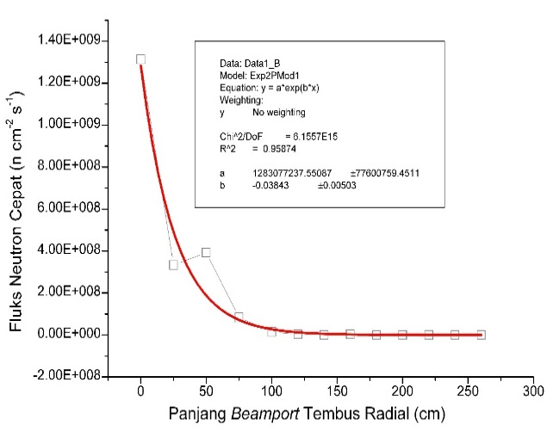

Figure 5. Graph of Beamport length Vs Fast Neutron Flux

Based on Figure 5, it was obtained the equation (6) where fast neutron flux expressed in y-axis and x-axis specifies the beamport length.

 (6)

Thermal Neutron Flux Maping

Collimator will be placed on the piercing radial beamport at a 118 cm distance from the reactor core. Figure 6 shows the placement of the neutron collimator in piercing radial beamport of Kartini Research Reactor.

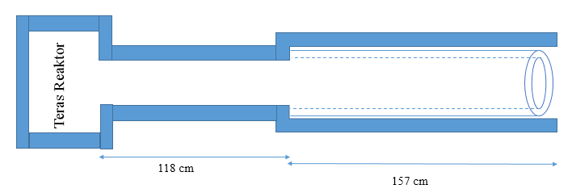

Figure 6. Placement of Collimator in Piercing Radial Beamport

Neutron flux wich is interacting with the neutron collimator are thermal neutron flux. The magnitude of the thermal neutron flux which interacts with neutron collimator vary in each neutron collimator segments. The magnitude of the thermal neutron flux which interacts in each segments of collimator can be determined using equation (5). Table 4 shows the magnitude of the thermal neutron flux which interacts with each collimator segments.

Table 4. Thermal Neutron Flux in Each Collimator Segments

|  |  |  |  |
| --- | --- | --- | --- |
| Segmen | Panjang (cm) | | Fluks neutron termal (ncm-2s-1) |
| x1 (cm) | x2 (cm) |
| 1 | 118 | 131 | 2,2942E+07 |
| 2 | 131 | 144 | 1,4708E+07 |
| 3 | 144 | 157 | 9,4289E+06 |
| 4 | 157 | 170 | 6,0447E+06 |
| 5 | 170 | 183 | 3,8751E+06 |
| 6 | 183 | 196 | 2,4843E+06 |
| 7 | 196 | 209 | 1,5926E+06 |
| 8 | 209 | 222 | 1,0210E+06 |
| 9 | 222 | 235 | 6,5454E+05 |
| 10 | 235 | 248 | 4,1961E+05 |
| 11 | 248 | 261 | 2,6901E+05 |
| 12 | 261 | 274 | 1,7245E+05 |

Laju Dosis Kolimator Saat Iradiasi

The activity of each collimator elements is an activity accumulation of each collimator segments. Table 5 shows the amount activity of every collimator elements in the irradiation time.

Table 5. Collimator Elements Activities in the Irradiation time

|  |  |  |  |
| --- | --- | --- | --- |
| Unsur | Aktivitas (Ci) | | |
| ti = 2 jam | ti = 4 jam | ti = 6 jam |
| Ni-65 | 5,4251E-06 | 8,5547E-06 | 1,0360E-05 |
| Mn-56 | 4,4649E-07 | 7,0749E-07 | 8,6006E-07 |
| Cr-51 | 2,1143E-08 | 4,2242E-08 | 6,3297E-08 |
| Hg-197m | 4,3165E-08 | 8,3888E-08 | 1,2231E-07 |
| W-187 | 1,5413E-09 | 2,9957E-09 | 4,3682E-09 |
| Co-60 | 6,9119E-12 | 1,3824E-11 | 2,0735E-11 |
| Cu-64 | 1,0606E-09 | 2,0119E-09 | 2,8651E-09 |

The results are shown in Table 5 shows that the longer the irradiation time, the greater the activity of each collimator elements.

When the collimator is irradiated, each constituent of collimator elements will be activated. It will become radioactive and emit radiation. Table 6 shows the magnitude of the dose rate produced by the collimator at a 50 cm distance from the end of the collimator. The total dose rate which is produced from neutron collimator is accumulated dose rate from each neutron collimator elements.

Table 6. Collimator Dose Rate in Irradiation Time

|  |  |  |  |
| --- | --- | --- | --- |
| Unsur | Laju dosis (mR/jam) | | |
| ti = 2 jam | ti = 4 jam | ti = 6 jam |
| Ni-65 | 6,3609E-04 | 1,0030E-03 | 1,2147E-03 |
| Mn-56 | 1,6256E-04 | 2,5759E-04 | 3,1314E-04 |
| Cr-51 | 1,9492E-07 | 3,8943E-07 | 5,8353E-07 |
| Hg-197m | 1,2964E-06 | 2,5195E-06 | 3,6734E-06 |
| W-187 | 1,9978E-07 | 3,8831E-07 | 5,6621E-07 |
| Co-60 | 3,7335E-09 | 7,4669E-09 | 1,1200E-08 |
| Cu-64 | 5,5171E-08 | 1,0465E-07 | 1,4903E-07 |
| Jumlah | 8,0040E-04 | 1,2640E-03 | 1,5328E-03 |

The results are shown in Table 6 shows that the longer irradiation time, the greater dose rate generated by neutron collimator.

Based on Table 6 data, it can be made the relationship between the irradiation time and the dose rate. Figure 7 until Figure 13 shows the relationship between the irradiation time and the dose rate for each collimator elements.

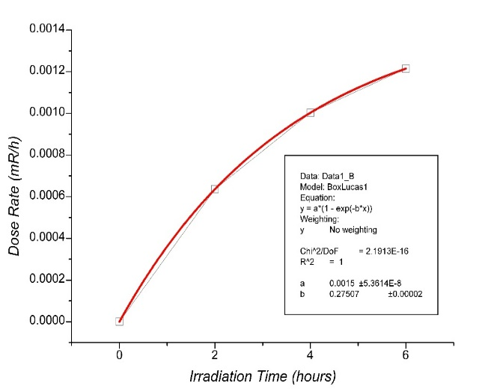

Figure 7. Graph of Irradiation Time Vs Dose Rate of Ni-65

Based on Figure 7, it was obtained the equation (7) where irradiation time expressed to x-axis and y-axis expressed the dose rate.

 (7)

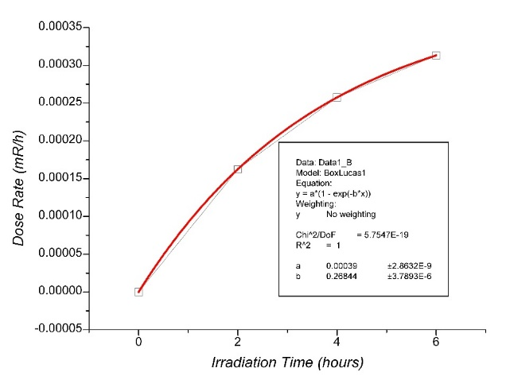

Figure 8. Graph of Irradiation Time Vs Dose Rate of Mn-56

Based on Figure 8, it was obtained the equation (8) where irradiation time expressed to x-axis and y-axis expressed the dose rate.

 (8)

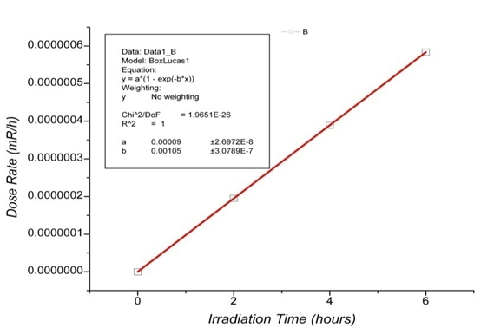

Figure 9. Graph of Irradiation Time Vs dose rate of Cr-51

Based on Figure 9, it was obtained the equation (9) where irradiation time expressed to x-axis and y-axis expressed dose rate.

 (9)

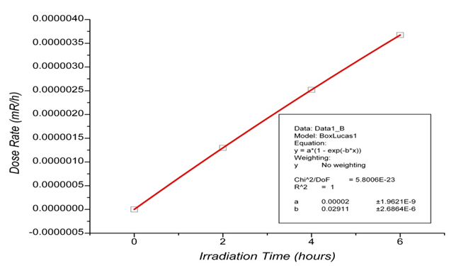

Figure 10. Graph of Irradiation Time vs dose rate of Hg-197m

Based on Figure 10, it was obtained the equation (10) where irradiation time expressed to x-axis and y-axis expressed dose rate.

 (10)

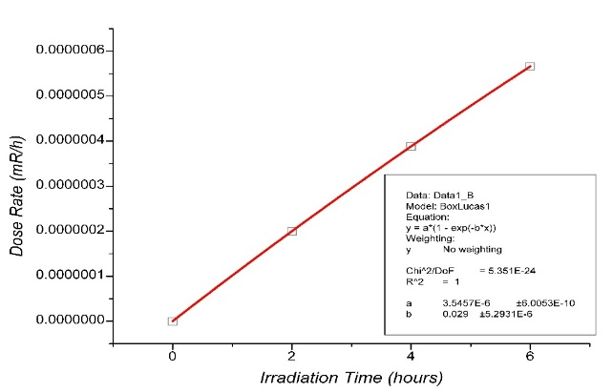

Figure 11. Graph of Irradiation Time Vs Dose Rate of W-187

Based on Figure 11, it was obtained the equation (11) where irradiation time expressed to x-axis and y-axis expressed the dose rate.

 (11)

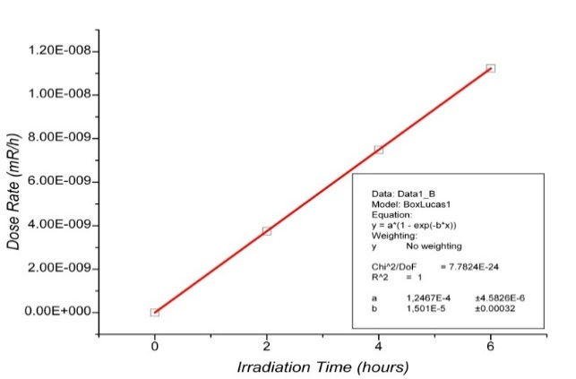

Figure 12. Graph of Irradiation Time vs Dose Rate of Co-60

Based on Figure 12, it was obtained the equation (12) where irradiation time expressed to x-axis and y-axis expressed the dose rate.

 (12)

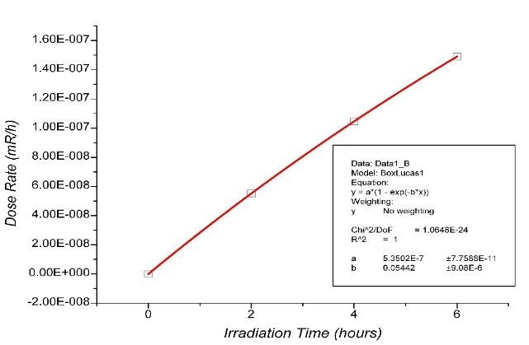

Figure 13. Graph of Irradiation Time Vs Dose Rate of Cu-64

Based on Figure 13, it was obtained the equation (13) where the irradiation time expressed to x-axis and y-axis expressed the dose rate.

 (13)

Collimator Dose Rate after 6 Hours Irradiation

After irradiated time for 6 hours was stopped, the activity of each collimator elements were decay. The total activity of each collimator elements are accumulation of each collimator elements activities. Table 7 shows the amount of every collimator elements activity after 6 hours irradiation time, whereas Table 8 shows the dose rate generated by a collimator at a distance of 50 cm from the end of the collimator after irradiated for 6 hours. The total dose rate which is generated by neutron collimator is accumulated dose rate of each collimators elements in each segments.

Table 7. Collimator Elemenents Activities After Irradiated for 6 Hours

|  |  |  |  |
| --- | --- | --- | --- |
| Unsur | Aktivitas (Ci) | | |
| td = 3 jam | td = 6 jam | td = 9 jam |
| Ni-65 | 4,5394E-06 | 1,9890E-06 | 8,7148E-07 |
| Mn-56 | 3,8438E-07 | 1,7179E-07 | 7,6778E-08 |
| Cr-51 | 6,3099E-08 | 6,2902E-08 | 6,2706E-08 |
| Hg-197m | 1,1207E-07 | 1,0270E-07 | 9,4105E-08 |
| W-187 | 4,0042E-09 | 3,6706E-09 | 3,3647E-09 |
| Co-60 | 2,0734E-11 | 2,0733E-11 | 2,0732E-11 |
| Cu-64 | 2,4336E-09 | 2,0671E-09 | 1,7558E-09 |

The results are shown in Table 7 states that the longer delay time, the lower activity of each collimator elements.

Table 8. Collimator Dose Rate After Irradiated for 6 hours

|  |  |  |  |
| --- | --- | --- | --- |
| Unsur | Laju dosis (mR/jam) | | |
| td = 3 jam | td = 6 jam | td = 9 jam |
| Ni-65 | 5,3224E-04 | 2,3321E-04 | 1,0218E-04 |
| Mn-56 | 1,3995E-04 | 6,2547E-05 | 2,7954E-05 |
| Cr-51 | 5,8171E-07 | 5,7989E-07 | 5,7808E-07 |
| Hg-197m | 3,3661E-06 | 3,0845E-06 | 2,8264E-06 |
| W-187 | 5,1903E-07 | 4,7578E-07 | 4,3613E-07 |
| Co-60 | 1,1200E-08 | 1,1199E-08 | 1,1199E-08 |
| Cu-64 | 1,2659E-07 | 1,0753E-07 | 9,1333E-08 |
| Jumlah | 6,7680E-04 | 3,0001E-04 | 1,3408E-04 |

The results are shown in Table 8 shows that the longer the delay time, the smaller the dose rate generated collimator elements.

Based on Table 8 data, it can be made the relationship between the delay time and the dose rate of each collimator elements. Figure 14 until Figure 20 shows the relationship between the delay time and the dose rate of each collimator elements.

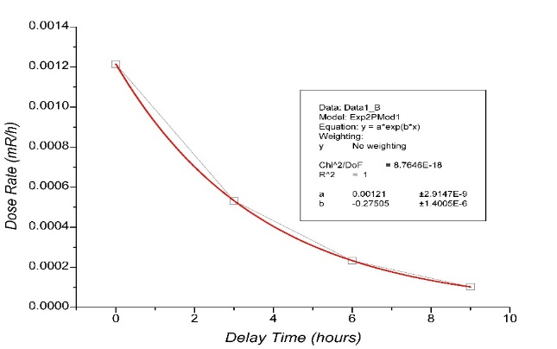

Figure 14. Graph of Delay Time Vs Dose Rate of Ni-65

Based on Figure 14, it was obtained the equation (14) where delay time expressed to x-axis and y-axis expressed the dose rate.

 (14)

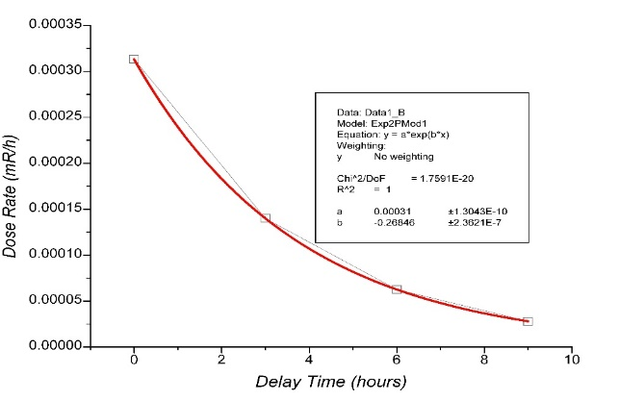 Figure 15. Graph of Delay Time Vs Dose Rate of Mn-56

Based on Figure 15, it was obtained the equation (15) where delay time expressed to x-axis and y-axis expressed the dose rate.

 (15)

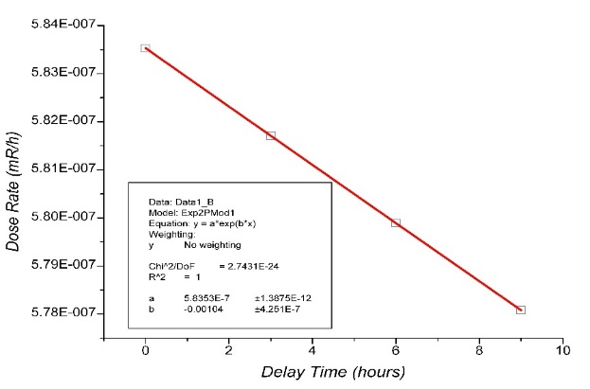

Figure 16. Graph of Delay Time Vs Dose Rate of Cr-51

Based on Figure 16, it was obtained the equation (16) where delay time expressed to x-axis and y-axis expressed the dose rate.

 (16)

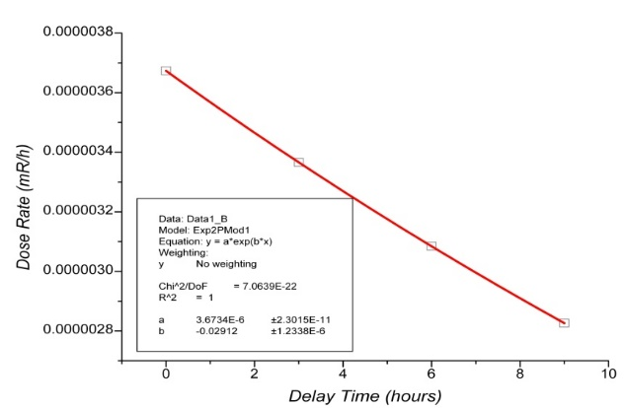

Figure 17. Graph of Delay Time Vs Dose Rate of Hg-197m

Based on Figure 17, it was obtained the equation (17) where delay time expressed to x-axis and y-axis expressed the dose rate.

 (17)

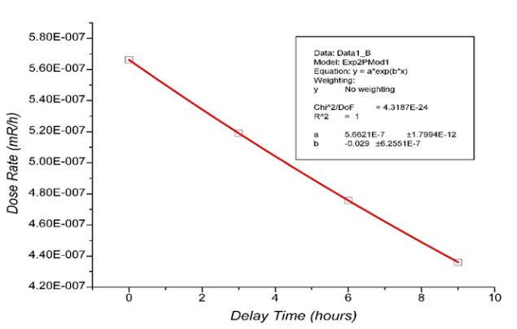

Figure 18. Graph of Delay Time Vs Dose Rate of Vs W-187.

Based on Figure 18, it was obtained the equation (18) where delay time expressed to x-axis and y-axis expressed the dose rate.

 (18)

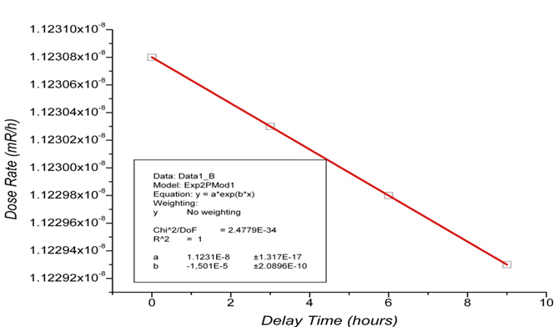

Figure 19. Graph of Delay Time Vs Dose Rate of Co-60

Based on Figure 19, it was obtained the equation (19) where delay time expressed to x-axis and y-axis expressed the dose rate.

 (19)

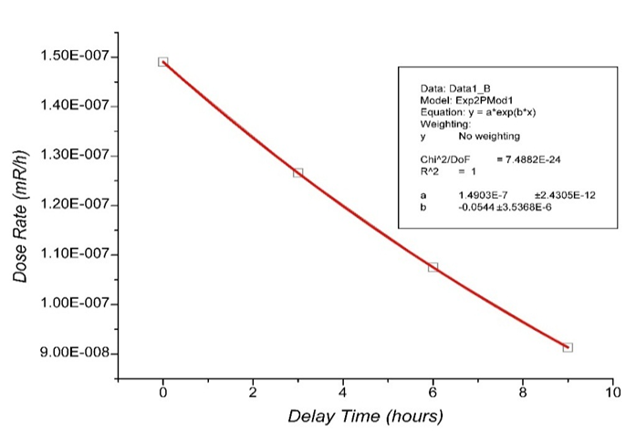

Figure 20. Graph of Delay Time Vs Dose Rate of Cu-64

Based on Figure 20, it was obtained the equation (20) where delay time expressed to x-axis and y-axis expressed the dose rate.

 (20)

CONCLUSION

The total dose rate genarated by neutron collimator at a distance of 50 cm from the end of the collimator after 6 (six) hours irradiation is 1,5328E-03 mR / h. The dose rate is lower than the dose limit which is authorized by BAPETEN (1 mR / h).

REMARKS

It is required α and β spectroscopy to study both α and β radiation which is may occur from collimator elements activity.

REFERENCES

[1] Mohammad Ilma Muslih Arrozaqi, Perancangan Kolimator Di Beamport Tembus Reaktor Kartini Untuk Boron Neutron Capture Therapy., Fakultas Teknik Universitas Gadjah Mada, 2013.

[2] *Indri S.N.,* ***Widarto****, Yosaphat S.,*

Desain Experiment Existing Parameters Physics untuk Mendukung Metode Boron Neutron Capture Therapy BNCT) pada Beamport Tembus Reaktor Kartini.

Bagian dari Buku dengan judul : **Status Boron Neutron Capture Cancer Therapy di Indonesi**a. Penerbit Jogja Bangkit Publisher : Yogyakarta, 2014

[3] BAPETEN, 2013, *Peraturan Kepala Badan Pengawas Tenaga Nuklir Nomor 4 Tahun 2013 tentang Proteksi dan Keselamatan Radiasi Dalam Pemanfataan Tenaga Nuklir*, Badan Pengawas Tenaga Nuklir, Jakarta

[4] Erdtmann Gerhard, *Neutron Activation Tables*, Weinheim Nem York: Verlag Chemie, 1976.

[5] Khoirunisa, 2015, *Analisis Jenis Dan Kadar Unsur Pada Bahan Kolimator Neutron Sebelum Dan Sesudah Manufaktur Menggunakan Metode Analisis Aktivasi Neutron (AAN)*, STTN-BATAN: Yogyakarta.

[6] Mujiyono., dkk., 2014, *Manufaktur Collimator BNCT Berbahan Nikel dengan Metode Gravity Casting dan Analisis Potensi Centrifugal Casting Sebagai Metode Alternatif,* Jogja Bangkit Publisher: Yogyakarta.

[7] Dwi Wahyuningsih, Optimasi Desain KolimatorUntuk Uji *In Vivo Boron eutron Capture Therapy* (BNCT) Pada *Beam Port* Tembus Reaktor KartiniMenggunakan Simulasi *Monte Carlo N Particle 5.* Program Studi S2 Ilmu Fisika FMIPA, UGM Yogyakarta, 2014

[8]Suparman, L., Y., 2011, *Penentuan Karakteristik Distribusi Fluks Neutron Thermal Fasilitas Iradiasi Lazy Susan (LS) Arah Horizontal Reaktor Kartini,* Skripsi Jurusan FMIPA Universitas Negeri Yogyakarta, Yogyakarta.

[9]Trikasjono, T., dkk, 2008, *Studi Penerimaan Dosis Eksterna Pada Pekerja Radiasi di Kawasan Batan Yogyakarta,* Prosiding Seminar Nasional IV SDM Teknologi Nuklir, Yogyakarta.

[10] Umbara, R., H., 2011, *Pedoman Keselamatan dan Proteksi Radiasi Kawasan Nuklir Serpong (Revisi 1)*, PUSPIPTEK Serpong: Tangerang Selatan.

[11] Wahyono, P., I., dkk, 2012, *Laporan Analisis Keselamatan (Rev.7)*, PTAPB-BATAN: Yogyakarta.

[12] Widarto., dkk, 2014, *Status Saat Ini Pengembangan Teknologi Dan Aplikasi Boron Neutron Capture Cancer Therapy Dengan Compact Neutron Generator*, Jogja Bangkit Publisher: Yogyakarta.

[13]Amiruddin, A., 2008, *Kimia Inti & Radiokimia,* PPIN-BATAN: Kawasan Puspiptek Serpong-Tangerang.

[14] Awaludin, R., 2009, *Pembuatan Nanopartikel Emas Radioaktif dengan Aktivasi Neutron*, PRR-BATAN: Kawasan Puspiptek Serpong-Tangerang.

[15] Stabin, Michael G .,2007, *Radiation Protection and Dosimetry*, Springer, New York.